Project Design Phase-II

Data Flow Diagram & User Stories

|  |  |
| --- | --- |
| Date | 22 – sep- 2023 |
| Team ID | NM2023TMID05015 |
| Project Name | GlobeTrek Insights: Navigating Global Country Data With IBM Cognos |
| Maximum Marks | 4 Marks |

# Data Flow Diagrams:

A Data Flow Diagram (DFD) is a traditional visual representation of the information flows within a system. A neat and clear DFD can depict the right amount of the system requirement graphically. It shows how data enters and leaves the system, what changes the information, and where data is stored.

# DATA FLOW DIAGRAMS :

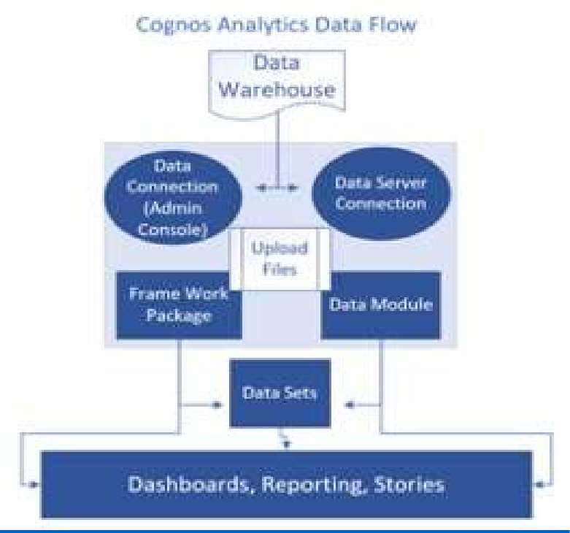

**User Stories**

Use the below template to list all the user stories for the product.

|  |  |  |  |  |  |  |
| --- | --- | --- | --- | --- | --- | --- |
| **User Type** | **Functional Requirement (Epic)** | **User Story Number** | **User Story / Task** | **Acceptance criteria** | **Priority** | **Release** |
| Marketing Manager | Data Analysis Capability | US001 | As a Marketing Manager, I want to access IBM Cognos Analytics to perform data analysis for campaign success. | * Log in to IBM Cognos Analytics. - Import marketing campaign data. * Analyze data to identify trends and insights. | High | Sprint 1.0 |
| Data Analyst | Data Visualization | US002 | As a Data Analyst, I want to create data visualizations in IBM Cognos Analytics for marketing campaigns. | * Access data in IBM Db2. * Create informative visualizations. - Customize dashboards. | High | Sprint 1.0 |
| IT Specialist | Data Security and Integration | US003 | As an IT Specialist, I want to ensure data security and smooth integration of IBM Cognos Analytics with IBM Db2. | - Configure secure data access. - Monitor data integration. - Implement  data security measures. | High | Sprint 1.0 |
| Finance Team | Budget Optimization | US004 | As a member of the Finance Team, I want to utilize data insights to optimize marketing campaign budgets. | - Access data-driven budget insights. - Analyze spending patterns. - Allocate budget  efficiently. | Medium | Sprint 1.1 |
| Compliance Officer | Data Privacy Compliance | US005 | As a Compliance Officer, I want to ensure legal data handling and GDPR compliance  when using IBM Cognos Analytics and IBM Db2. | - Implement data privacy measures. - Monitor  GDPR compliance. - Protect customer data. | High | Sprint 1.0 |
| Project Manager | Project Coordination | US006 | As a Project Manager, I want to coordinate the efforts of the team to implement data analysis for marketing campaigns successfully. | - Define project milestones. - Coordinate data analysis tasks. - Monitor project progress. | High | Sprint 1.0 |
| Customer Support | Improved User Experience | US007 | As a Customer Support representative, I want to gather customer feedback and use data insights to enhance user experiences. | - Collect customer feedback. - Address  concerns effectively. - Improve user satisfaction. | Medium | Sprint 1.1 |
| CEO/Manag ement | Alignment with Goals | US008 | As CEO/Management, we want to ensure that data analysis aligns with our company goals and supports informed decision-making. | - Review data analysis strategy. - Assess the alignment with goals. - Support strategic decisions. | High | Sprint 1.0 |

|  |  |  |  |  |  |  |
| --- | --- | --- | --- | --- | --- | --- |
| Sales Team | Data-Driven Sales | US009 | As a member of the Sales Team, I want to leverage data insights from data analysis to convert leads into sales effectively. | - Utilize data-driven insights. - Convert leads successfully. - Collaborate with the marketing team. | Medium | Sprint 1.1 |